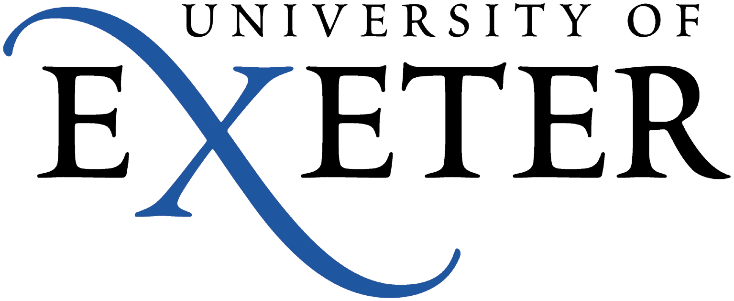
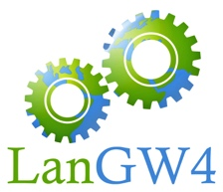

Sixth LanGW4 Colloquium on

Innovation in Modern Languages Education

University of Exeter, Friday 21st June 2019

Programme
10:00-10:30 | Registration & refreshments
10:30-11:30 | Opening and welcome from the University of Exeter  - Professor Adam Watt, Head of the Department of Modern Languages  - Ms Isabel Moros (Co-Director of LanGW4)  Keynote speaker: Professor Debra Kelly, Kings College London and Deputy Director of ‘Language Acts and World Making: Using research creatively to create a Worldmaking community’
11:30-12:45 | 1st Round Table: Do we still need to teach Grammar and how?  Moderator: Dr Irene Macías, University of Bath  - Beatriz Rubio Arribas and Ester Borin-Bonillo (Cardiff University): Engaging students in how to ensure meaningful, comprehensive and worthwhile feedback with Digital Self Marking tools on Grammatical Exercises  - Kiyo Roddis (Cardiff University): Teaching and Learning Grammar Implicitly through Contextualisation and Personalisation: Practice from UWLP Japanese courses  - Nadia Nebot and Nazaret Pérez Nieto (Cardiff University): New Approaches to teaching Grammar  - Q&A (15 mins)
12:45-13:45 | Lunch
13:50-15:15 | 2nd Round Table: Mediation  Moderator: Dr Isabel Santafé, University of Exeter  - Florence Gomez (University of Exeter): What can mediation do for Modern Languages in Higher Education?  - Vera Castiglione and Stefania Placenti (University of Bristol): Developing intercultural competence: The Year Abroad in the Oral Class  - Marie Gastinel Jones and Cathy Molinaro (Cardiff University): Building Connections: An evidence-based study of mediation through the online cultural and language BILI exchange  - Natalia Pinazza (University of Exeter): Multiculturality and Polycentrism in the Mediation of Portuguese Language

15:20-15:55 | Discussion and debate about the different practices for the Year Abroad:  Moderator: tbc  - Nadia Nebot and Nazaret Pérez Nieto (Cardiff University)  - Irene Macías (Bath University) tbc  - Vera Castiglione (Bristol University) tbc  - Chloe Paver/Steven Bassett (Exeter University) tbc  - Students’s voices  - Q&A (10 mins)
16:00 | Closing comments

VENUES:
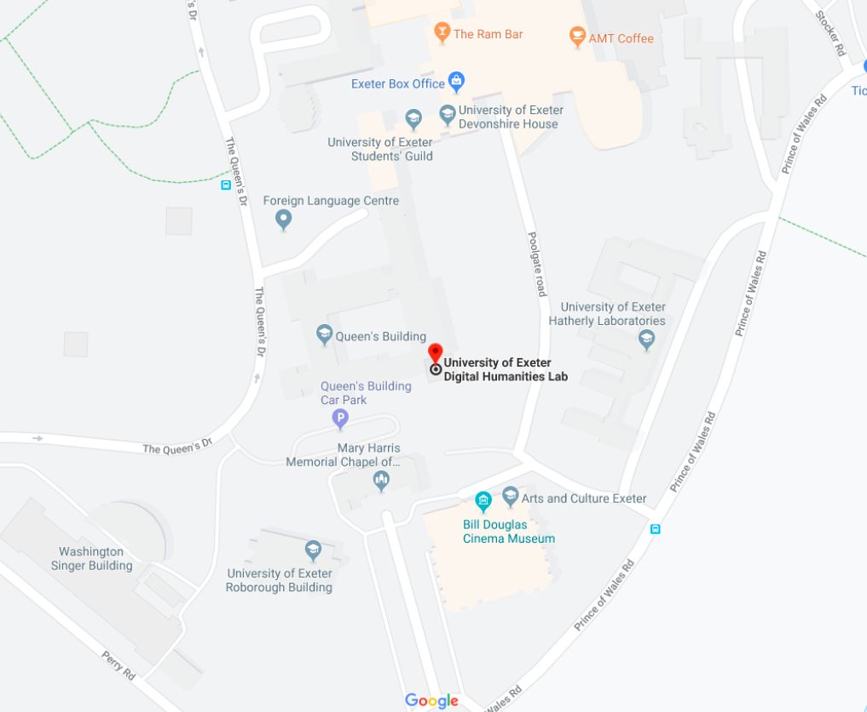
REGISTRATION AND REFRESHMENTS:

Seminar Room 1, Digital Humanities Lab
The Queen’s Dr, Exeter EX4 4QH
University of Exeter

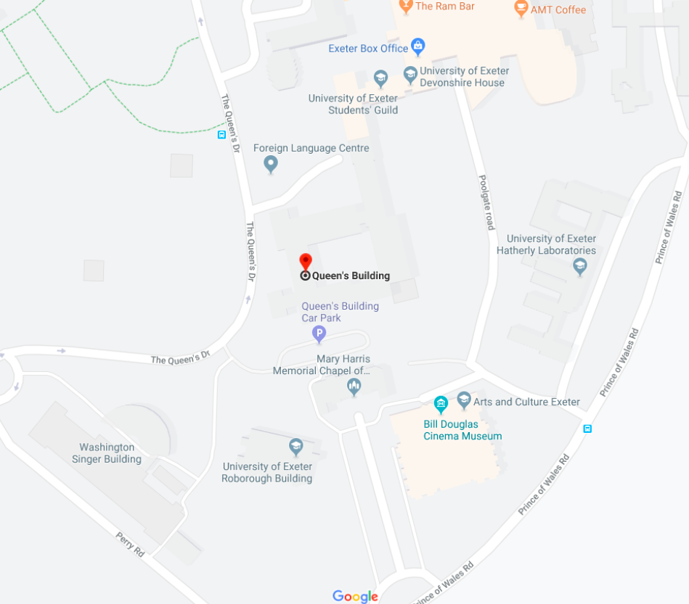

THE EVENT:

Lecture Theatre 1 (LT1), Queens Building
The Queen’s Dr, Exeter EX4 4QH
University of Exeter

Executive Committee and Organisers
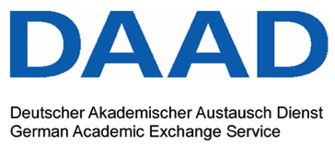
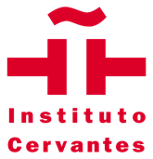

Isabel Moros, University of Exeter
Dr Vera Castiglione, University of Bristol
Marie Gastinel-Jones, Cardiff University
Dr Irene Macías, University of Bath
